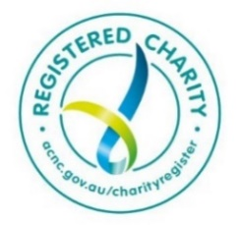

**Assist-to-Succeed (ATS) Consulting**

**Who are we?**

We are a team of experienced professionals who wish to use our many years of experience to benefit our community. We utilise our skills and experience to assist charitable and non-profit-making community groups.

Our group is a registered charity. All our work is pro-bono and we are only funded by donations.

Our diverse group is composed of professionals from diverse backgrounds including senior management, consulting, business development, engineering, finance, project management and information and communication technology.

We advise, guide, consult and review in order to promote management maturity and self-sufficiency.

We often contribute by taking an active and longer-term partnership on advisory groups and steering committees responsible for key initiatives or by providing advice to key executives on a one-on-one basis.

We are valued for our independence, free of organisational politics or the motivation to attract fee-paying business.

**What we do**

|  |  |  |
| --- | --- | --- |
| **Finance and Business Plans** | **Management**  Strategy  Bus architecture  Change  Governance | **Project Delivery**  Planning  Tracking  Post impl reviews |
| **Workshops**  Planning  Strategy  Decision Making | **Business Development** | **Technology**  Strategy  Tenders  Architecture |

**Examples of Engagements**

**Reviewed process and system issues including interviewing relevant staff & reporting to senior management and the board.**

**Member of steering committees and advisor for various types of change programs and system implementations**

**Reviewed an organisation’s financial issues and recommend potential remediations**

**Assisted to develop a target state operating model of the core business prior to RFPs**

**Reviewed and helped to improve the business cases for strategic business initiatives**

**Reviewed client’s business and ICT strategies and initiatives, alignment & 3-year plan in order to validate and refine**

**Conducted workshops as an independent party to assist strategic planning & organisational decision making**

**Assisted with the selection of a replacement core business system including the RFT process & sat on the project review board**

88